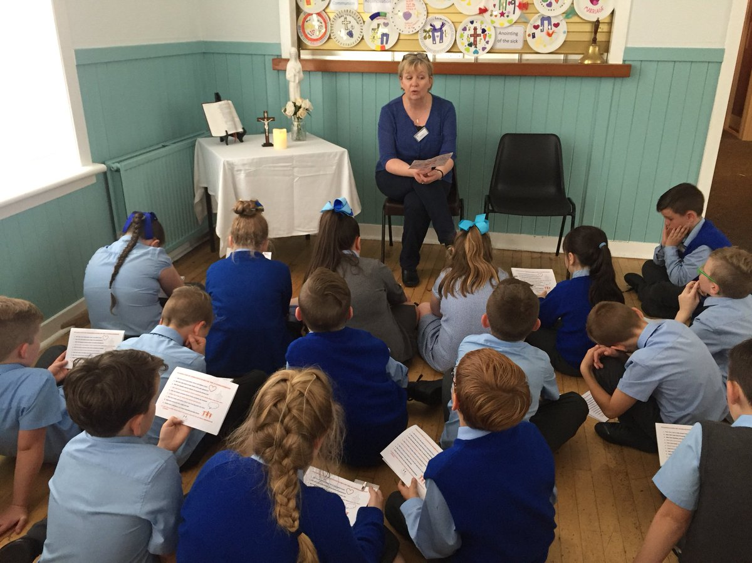  How to book a Pr5 School Retreat  - Contact local parish to get list of suitable dates  - Contact Retreats Team to find a mutually suitable date  - Cost: £3 per child for 1 retreat,  £5 per child for 2 retreats and  £7 per child for all 3 retreats  (Please check that parish will cover hall charge). |  |  | The Retreats Team  Retreat Team Leader  Stephanie McCrossan  Primary RE Adviser  Claire O’Neill  Retreat Assistant  Barbara Ramage  Contact Us  Phone: 01698 269114 (option1)  Email: retreats@rcdom.org.uk  Primary 5 School Retreats  Diocesan Centre  Coursington Road,  Motherwell  ML1 1PP |  |  | Primary 5 School Retreats  - Diocese of Motherwell

Primary 5 Retreats  A retreat can be a very special way to enhance the RE work the children are doing in school and in the Diocese of Motherwell, our school retreats complement 3 of the Pr5 planning themes for This Is Our Faith. These themes are:  Healing-Jesus & the Sacraments (available August-October)  Disciples-Calling & Response (available October-December)  The Eucharist (available January-April)  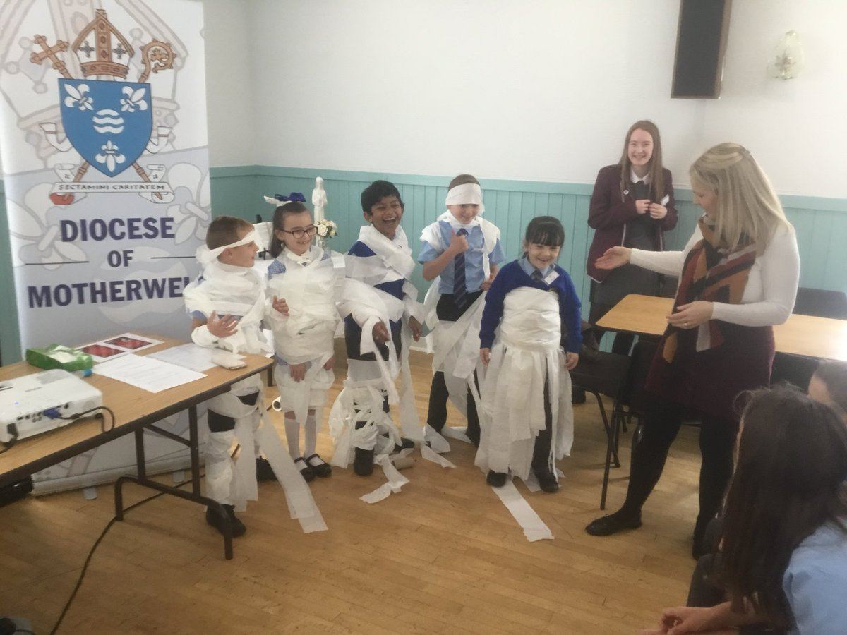  In Term 4, any of the three retreats are available on request. |  |  | A School/Parish Initiative  Our retreats offer a unique opportunity to strengthen the school/parish link. The main venue for each retreat will be the corresponding parish hall.  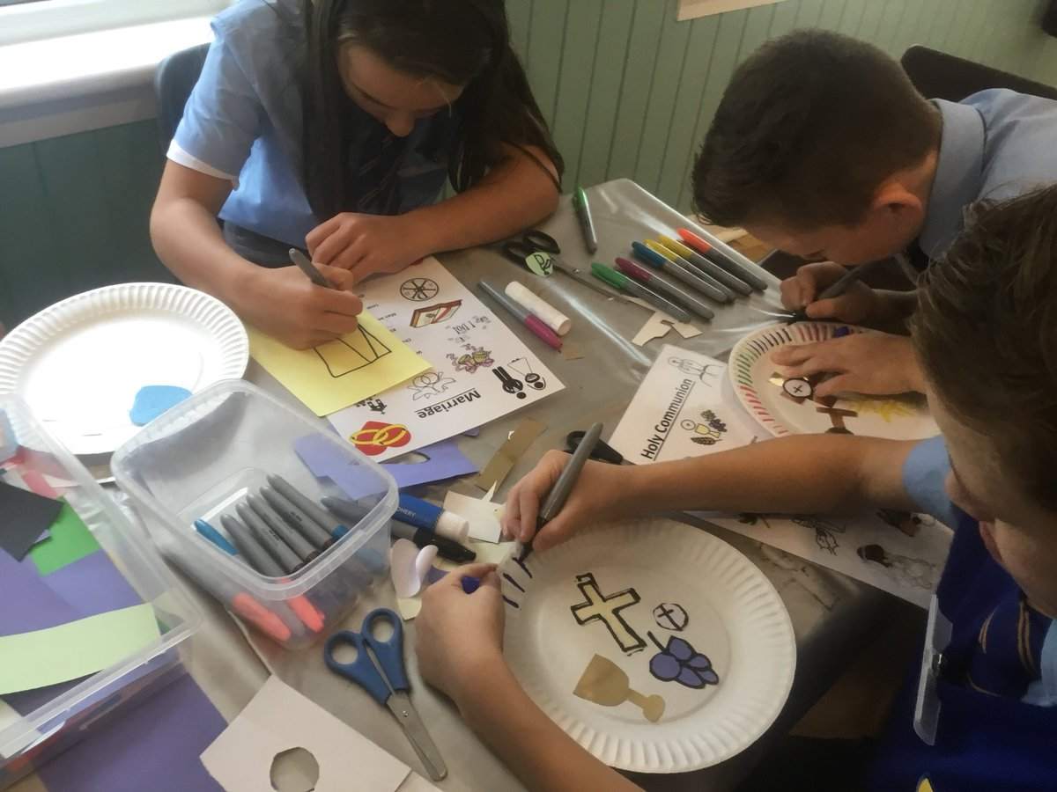  The Benefit of a Parish Based Retreat  - Reduced costs to schools  - Reduced/no travelling expenses  - Children recognise parish as a centre for a variety of prayer/devotional activities rather than only for Sunday/First Friday Mass  - Retreat team accompany children to the hall and on return  - Increased opportunities for stakeholder involvement i.e. parental and parishioner supporters  - Materials provided to prepare for upcoming retreat  - Materials provided for use following retreat |  |  | 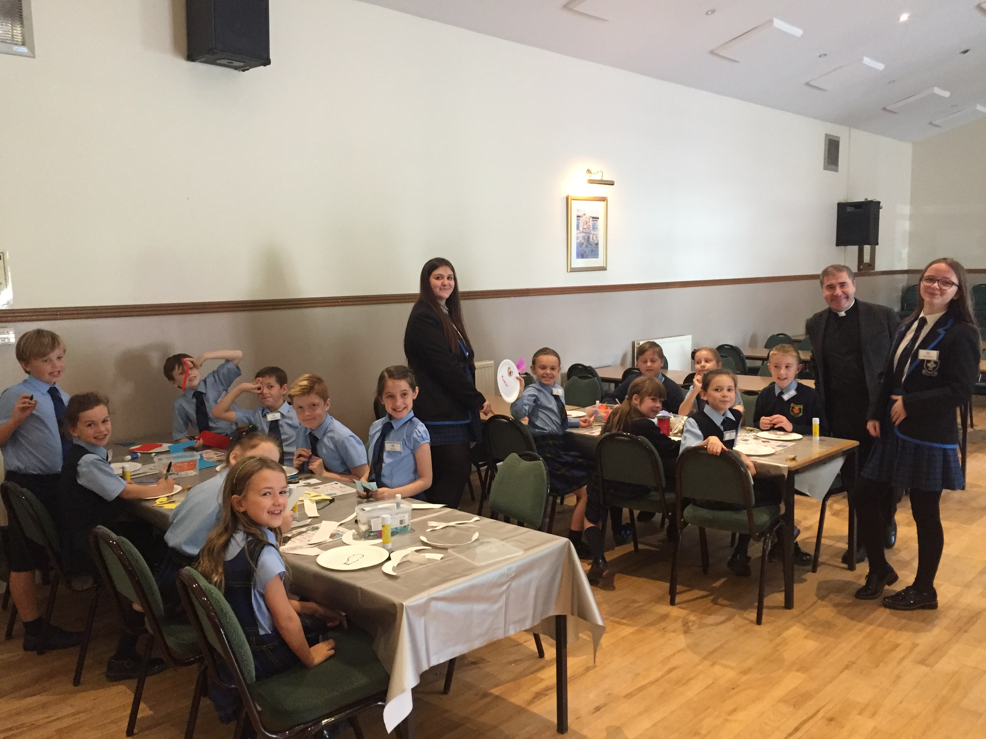  A Typical retreat  - Preparation prayers and scripture sent to schools to be used in the week prior to the retreat  - Retreat team leader comes to school to begin the day with a short prayer service  - In pilgrimage fashion, the class and their teacher are accompanied by the Retreats Team Leader to the hall  - Children will participate in three group based rotational activities including a variety of forms of prayer and devotion, arts and crafts, songs and games.  - During break and lunch, children are led by retreat staff for fun games/activities  - Children are escorted by Retreats Team Leader back to school  - A plenary activity is organized for the teacher to do with the children  - A pack containing teachers’ notes, music CD and children’s’ booklet is provided for 4 additional sessions which can be used by the teacher to complement the retreat day and extend learning.

